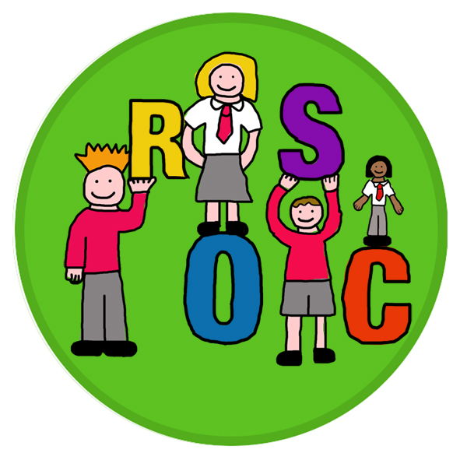

Ralston Out of School Care
School Road
Paisley
PA1 3AT
Tel: 0141 882 5230

Out of School Care Booking 2023/24 booking

In order to ensure sustainability of service, and continuity for the children currently in our care, we have attached a booking request form for the year 2023/2024 commencing in August 2023.

Fee information and tariffs are available on request.

Please note that to reduce costs we ask that you return this form electronically and copy your signed document before returning for your records.

If you have any questions please do not hesitate to contact us by email ralston.osc@hotmail.co.uk by telephone on 0141 588 4273 or in person any afternoon at the service.

Yours sincerely,

Ralston Out of School care

Child Registration
Childs Name :
D.O.B. |  |  |  |  |  |  | Primary Class
Primary carers details |  | Name : |  |  |  |  | Name :
Home Telephone No
Work Telephone No
Mobile Telephone No
Email address
Address

Emergency contact 1 |  | Name |  |  |  |  | Contact number
Emergency contact 2 |  | Name |  |  |  |  | Contact number
Who has parental responsibility?
Are there any contact restrictions? (If yes give details below)
Collection of children from service
Name |  | Mobile number
I understand that the service closes each evening at 6pm and that there will be a fee charged if my children are not collected by 6pm.
Medical Information
Name of Doctor
Surgery Address
Surgery Contact Number
Does your child suffer from any conditions requiring medical treatment including medication?
If YES, please give brief details

Please state any other relevant information regarding your child’s health including details of any serious illness.

Does your child have any allergies? Please tick all those that apply None
Dairy produce |  |  | Lactose |  |  | Gluten |  |  | Strawberries
Lentils |  |  | Tomatoes |  |  | Eggs |  |  | Peanuts
Caffeine |  |  | Food Colourings |  |  | Fish
Dust |  |  | Pet Hair |  |  | Pollen |  |  | Other
If yes to any of the above, please give details and what is recommended to treat these allergies.

Does your child require the use of an EPI pen in relation to allergic reactions?

If yes you will be required to supply ROSC with an EPI Pen
Does your child have any food intolerances or dietary requirements?

Does your child have any additional support needs?

I undertake to inform the service as soon as possible of any change in medical circumstances during my child’s attendance at ROSC.
If all attempts to contact me fail, I agree to my child receiving emergency medical treatment, including anaesthetic, as considered necessary by the medical authorities present.

Other important information.
Please detail any other important information that is relevant to your child.

Thank you for taking the time to complete this form.
It is essential that ROSC always maintains the correct information regarding your child. If any of your child’s details change, please inform ROSC immediately.

Please check all the details above and ensure you add any additional information. Please sign below to conform all the details and statements above.

Name
Signature
Date

Permission Form

Childs Name Parents Name

Please see below our consent table to be completed. If anything changes, please inform ROSC staff in writing.

Permission required. | Notes (if applicable) | Please tick
Sun cream to be applied | Staff will apply our sun cream to children before going out if they feel it is necessary. Children without sun cream will be unable to go outside on hot days.  If you wish to provide your own, please ensure this is labelled with your child’s name and handed into the service.
Face paints and nail varnish etc | As part of an activity
Water Play | Please ensure children have a spare change of clothes for water play days. Advanced notice will be given.
Photographs | Permission to take photographs of children to be used internally for records as well as our closed Facebook group.  Permission will be requested for any outside agencies if applicable.
Internet Access | Permission for children to access the internet through supervised activities organised by ROSC staff.

Parents Signature Date

Ralston Out of School Club

Privacy Notice
At Ralston Out of School Club we respect the privacy of the children attending the Club and the privacy of their parents or carers. The personal information that we collect about you and your child is used only to provide appropriate care for them, maintain our service to you, and communicate with you effectively. Our legal basis for processing the personal information relating to you and your child is so that we can fulfil our contract with you.
Any information that you provide is kept secure. Data that is no longer required* is erased after your child has ceased attending our Club.
We will use the contact details you give us to contact you via phone, email, social media and post, so that we can send you information about your child, our Club and other relevant news, and also so that we can communicate with you regarding payment of our fees.
We will only share personal information about you or your child with another organisation if we:
- have a safeguarding concern about your child
- are required to by government bodies or law enforcement agencies
- engage a supplier to process data on our behalf (e.g. to take online bookings, or to issue invoices
- have obtained your prior permission.
You have the right to ask to see the data that we have about yourself or your child, and to ask for any errors to be corrected. We will respond to all such requests within one month. You can also ask for the data to be deleted, but note that:
- we will not be able to continue to care for your child if we do not have sufficient information about them
- even after your child has left our care, we have a statutory duty to retain some types of data for specific periods of time* so can’t delete everything immediately.
If you have a complaint about how we have kept your information secure, or how we have responded to a request to access, update or erase your data, you can refer us to the Information Commissioner’s Office (ICO).
Please sign and date below to confirm that you have read this Privacy Notice and that you give your permission for us to contact you regarding relevant matters.
Signed Date
Name:
* We do need to retain certain types of data (such as records of complaints, accidents, and attendance) for set periods of time after your child ceases to be in our care, but we delete as much personal data as we can as soon as possible.

Trip consent form
Childs Name:

- CONSENT I give my permission for the above to go any day trips with Ralston Out of School Care. This includes walking, using public transport and using hired vehicles. I acknowledge the need for obedience and responsible behaviour on their part.

- MEDICAL INFORMATION
(a) Does your child suffer for any conditions requiring medical treatment, including medication? YES/NO if YES, please give brief details

________________________________________________________________________

________________________________________________________________________

(b) Is your child allergic to any medication? YES/NO If YES, please specify
_______________________________________________________________________

(c) Has your child received a tetanus injection in the last five years? YES/NO

(d) Please outline any special dietary requirements of your child

________________________________________________________________________

I undertake to inform ROSC mangers of any changes in medical information as soon as possible

- DECLARATION I agree to my child receiving emergency medical treatment, including anaesthetic, as considered necessary by the medical authorities present. I understand the extent and limitations of the insurance cover provided.

I may be contacted by telephoning the following numbers:

Home:
Work:

If not available at the above, please contact:

Name Tel

Name, address and telephone number of family doctor:
Mirin medical practice paisley
________________________________________________________________________

Date Signed

ROSC Contract

- The signatory is responsible for collecting the child unless some prior arrangements have been made in writing with the service. The register must be signed when checking the child both in and out of the project. It is imperative that the service has copies of signatures of anyone who is authorised to collect the signatories’ child.

- Ralston out of School Care cannot provide care for children before 8am and after 6pm. If the parent/ guardian designated to collect the child in unavoidably delayed the signatory is responsible for informing the ROSC before the agreed pick up time. Failure to adhere to this requirement may result in our child protection policy being implemented and Social Work services being contacted.

- If a child’s behaviour is seen to be dangerous to his/herself or others, the service has the right to exclude the child from attending the service until such times as appropriate measures have been taken by parents/ guardians to discontinue this behaviour. Failure to put in place adequate measures may result in the ultimate termination of the service.

- At least 4 weeks’ notice is required for any alteration to the times and or dates of the place. Changes to placement will take effect on the 1st day of the month following formal notification of the change in service.

- Fees for the service will be spread over the 11 months from August to June and require to be paid by monthly standing order, in advance between 1st and 10th of each month. As with all places in Ralston Out of School Care parents of children in primary one will also be charged from the beginning of August in order to guarantee the placement. Where a Childs account falls into 2 months arrears ROSC reserves the right to suspend the service until the account is brought up to date in full.

- All parents/ guardians and children agree to adhere to the service rules as attached.

- Failure to comply with the conditions of this contract may lead to the contract being terminated and the loss of the placement with Ralston Out of School Care.

Childs Name:

Parent/Guardian Name:

Signed Date

Payment Method

I understand that my monthly fees are due between the 1st and 10th of each month, from August 2023 – June 2024.

The method of payment I will be using is (please tick appropriate method):

Childcare Voucher

Standing Order (set up direct)

Standing orders should be set up to begin in August, bank details can be found below:

Ralston Primary Out of School Care
Bank of Scotland
Sort code: 800746
Acc no: 00385061

Please ensure you use your child’s name as a reference to allow us to identify your monthly payment. If you require a standing order mandate form, please speak to a member of ROSC staff and return this along with update.

Booking Request Form

Name of Parent/Guardian
Morning session 8am-9pm

Child name | Class |  | Mon | Tues | Wed | Thur | Fri
Afternoon session 3pm- 6pm

Child name | Class |  | Mon | Tues | Wed | Thur | Fri
Monthly cost
Parents signature

For office use only
Date received
Staff signature

Collection Signature Sheet

This form is required for sample signatures of all adults (including parents) who may collect your child from out of school are.

An adult will only be allowed to collect your child if they named below, and a sample signature is provided

Child/Children’s name

……………………………………………….

………………………………………………

……………………………………………….

Name | Signature

